C++ goto Statement

In C++ programming, goto statement is used for altering the normal sequence of program execution by transferring control to some other part of the program.

## Syntax of goto Statement

goto label;

... .. ...

... .. ...

... .. ...

label:

statement;

... .. ...

In the syntax above, label is an identifier. When goto label; is encountered, the control of program jumps to label: and executes the code below it.

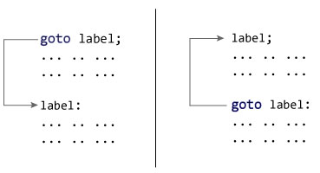

### Example: goto Statement

// This program calculates the average of numbers entered by user.

// If user enters negative number, it ignores the number and

// calculates the average of number entered before it.

# include <iostream>

using namespace std;

int main()

{

float num, average, sum = 0.0;

int i, n;

cout << "Maximum number of inputs: ";

cin >> n;

for(i = 1; i <= n; ++i)

{

cout << "Enter n" << i << ": ";

cin >> num;

if(num < 0.0)

{

// Control of the program move to jump:

goto jump;

}

sum += num;

}

jump:

average = sum / (i - 1);

cout << "\nAverage = " << average;

return 0;

}

**Output**

Maximum number of inputs: 10

Enter n1: 2.3

Enter n2: 5.6

Enter n3: -5.6

Average = 3.95

You can write any C++ program without the use of goto statement and is generally considered a good idea not to use them.